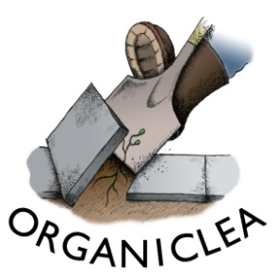
OrganicLea Recruitment - Volunteer roles
Traineeship Application Form
This form gives a structure for describing your interest in the trainee role and your previous experience. We know sharing things in writing doesn’t work well for everybody, so if it suits you better you can answer question 2 (the main question) with a voice note or video, and provide the link to this below.
If you have additional support needs and would benefit from some support to complete this form, please let us know on EMAIL or PHONE and we can arrange for someone to guide you through how to apply. Our aim is to remove barriers from the application process so please let us know if there is another way we can best support you to share your information with us.

1. Contact details

2. Your interest in this role
Please write a brief statement explaining why you are interested in this role including:
a) what experience and skills you can bring to the role, including how you meet the person specification. This means describing how you match each of the points listed under ‘Person Specification’ at the end of the Trainee Role Description document;

b) why you are interested in a voluntary traineeship with OrganicLea;

c) which traineeship role(s) are you are applying for? If you would like to apply for more than one role, please list your preferred two or three in order below:
1
2
3

3. Your work history
Please provide details of your paid and unpaid work history, including the month/year you started and finished each role, and the key responsibilities in it. You can copy this from your CV if you wish.

4. Your training and education
Please provide details of any relevant training or education including dates and qualifications achieved. You can copy this from your CV if you wish.

5. Other opportunities - Placements
Alongside traineeships we have several three month volunteer placements during May, June and July and regular volunteer harvesting roles across the year. They are linked to our production work in the glasshouse, the spring field, or the salad terrace, and harvesting work on Tuesdays. If we aren’t able to offer you a trainee role, would you be interested in applying for a three month volunteer placement or a volunteer harvesting role? If so, please tick the box below and we will send you that information when we advertise the placements in March.
Yes, I am interested in other volunteer placements, please send me details when you advertise.

6. Equal Opportunity Monitoring Form
Please complete our online monitoring form which you can access here. The information you provide will be kept completely separate from the recruitment process, but will enable us to review our recruitment and monitor whether we are meeting our commitments to improve equity and representation in our organisation.

7. Disability Confident - adjustments to interview and guaranteed interviews
We are committed to becoming a fully Disability Confident employer. Please let us know if you have a disability, consider that you meet the essential criteria for the role and would like a guaranteed interview. Please also advise of any reasonable adjustments you require during the recruitment process. You do not need to provide any details of your disability at this stage. If you prefer to have a telephone conversation about this rather than putting details on the form, please simply provide a contact number here.

Data Protection
OrganicLea takes care to ensure that we use your information in accordance with all applicable laws concerning the protection of personal information. Please see more details at https://www.organiclea.org.uk/about/privacy-notice/

