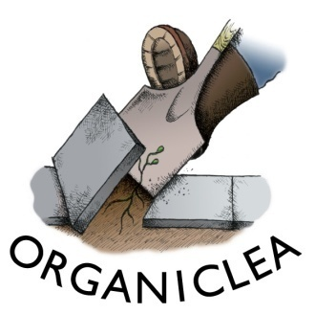
Salad Starter:
Two Enterprise Start-Up Placements

We grow organic produce at Hawkwood, our 12 acre community market garden and plant nursery, and distribute it to our own market stalls, box scheme and local restaurants. In 2017 we produced over
2.2 tonnes of salad leaves, featuring 107 different varieties of leaf.

We believe that more food should be grown organically and locally, and yet we cannot meet the demand, notably for salad. Following on from our Farm Start programme of supporting new entrants into organic farming, we are looking for two people to assist with, and learn about commercial salad growing; to progress to managing their own salad rotations at Hawkwood, before graduating to their own site. OrganicLea is committed to supporting them in finding an appropriate site, and providing them with growing, marketing and next-steps support throughout the process.

This placement will suit someone looking to develop a food growing enterprise in East London.

Deadline for applications: 5 pm on Friday 2nd February
Interview date: Friday 9th February

To apply: Please send a CV or employment (and volunteering) history and covering letter detailing how you meet the person specification and why you want this post to ru@organiclea.org.uk. For more information about this role please call Ru on 020 8524 4994.

Details of the role
- Unpaid voluntary role
- Travel expenses, within London, if needed

• A seasonal, vegan, organic lunch will be provided on Wednesdays
- Dates: Tuesday 6 March – Wednesday 31 October 2018
- Time commitment: 1.5 days per week (Tues and Weds) until mid-June; 1 day pw mid June onwards, with optional extra ½ - 1 day.
- Hours: Tuesdays from 9.00am – 5.00pm and Wednesdays 9.00am - 1.00pm
- Based at: Hawkwood Community Plant Nursery
- Supported by and responsible to: OrganicLea’s Production Support Worker

Main objectives

To learn about and assist with all aspects of propagation in the glasshouses

To learn about and assist with all aspects of planting and maintaining the salad growing areas of the Hawkwood site

To assist with harvesting and preparing produce in accordance with the needs of the OrganicLea stall, box scheme or other independent outlets

To provide support for the vegetable production at Hawkwood

To gain the necessary skills, confidence, contacts and support to run a successful salad growing enterprise in East London

Graduating to managing a salad area, and with consultation, making decisions about the planting, maintenance and harvest schedule.

Main Activities

Growing
- Formulating propagation media
- Raising plants from seed
- Irrigation
- Preparing ground, planting and maintaining salad crops, green manures and companion plants
- Organic weed, pest and disease management
- Harvesting schedules and techniques
- Winterising salad beds
- Undertake other activities in support of OrganicLea, as appropriate

Harvesting
- Cutting/picking produce to the agreed methods, ensuring quality control
- Preparing produce according to ‘product descriptions’
- Weighing, packaging, sealing, labelling and organising dispatch

Person Specification

Essential
- Interest in sustainable food production and the desire to put that interest into practice
- Some experience of growing
- Happy to work mainly outdoors throughout the year
- Ability to carry out shared tasks and work within a team
- Ability to work on own initiative, prioritise tasks and work to deadlines
- Commitment to and understanding of the aims of OrganicLea

