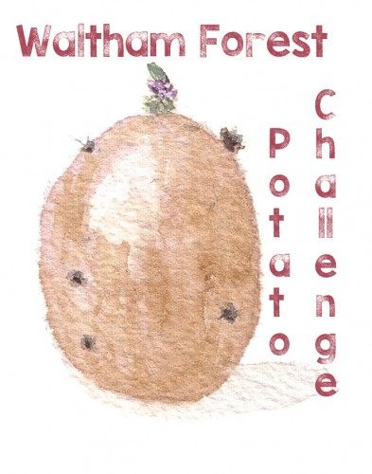

2015 is the year of the soil: This project aims to investigate how healthy soil can help potatoes grow.

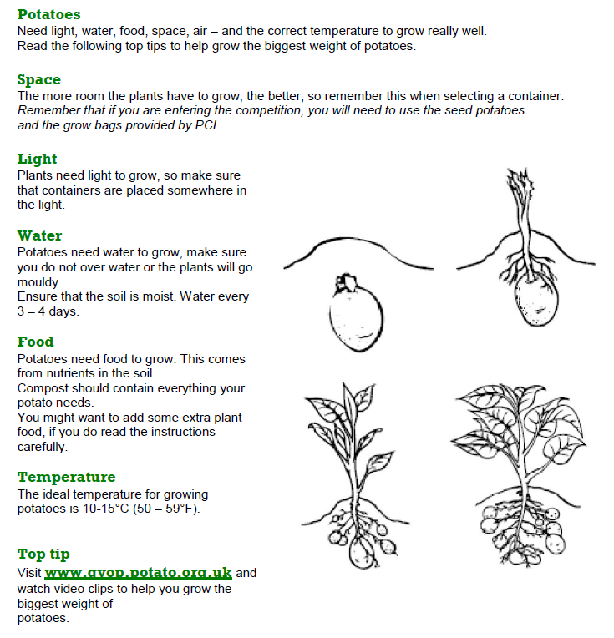

Growing Experiment: Does the soil matter?

We are looking at maximising yield, using local and sustainable resources. Below are all the things the potato plant needs to thrive. As an experiment, you can keep each condition the same but only change the type of soil used. We will provide you with compost from London waste, made from food and garden waste of London house-holds. You can compare it with some top soil you might find somewhere in your school ground which has not had organic matter or fertilizer added. It is easier to keep conditions the same if you do this experiment using grow bags. Keeping the number of potatoes planted in each one the same.

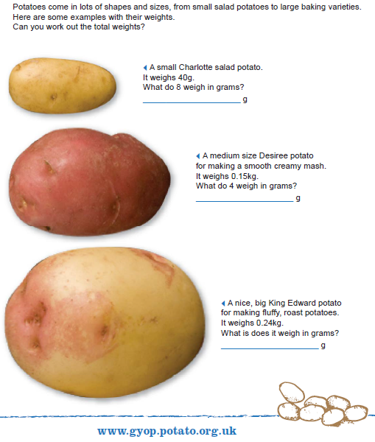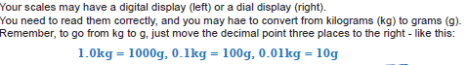

Recording results:

Weigh the seed potatoes planted and the harvested potatoes at the end of the season without soil. Record the results in the table below and find the increase for each soil type.

The Results

|  |  |  |  |  |
| --- | --- | --- | --- | --- |
| Soil type | Weight before | Weight after | Weight after/Weight before | Health of the plant |
| London waste |  |  |  |  |
| Top soil |  |  |  |  |
| Type 3 |  |  |  |  |
| Type 4 |  |  |  |  |

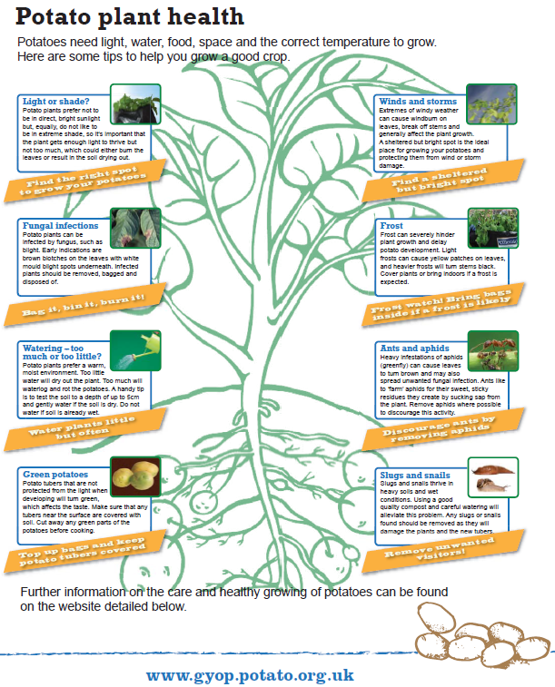

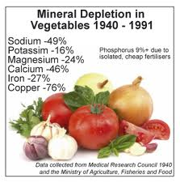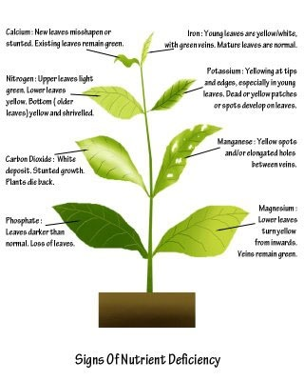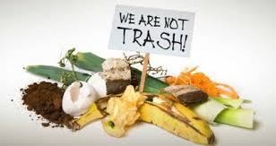

**London Waste Compost.**

## We recycle organic waste into quality compost for use in agriculture, allotments, community growing projects and gardens across North London.

Whether it’s grass cuttings, foliage or kitchen scraps delivered by your local council to our EcoPark CompostCentre we blend, shred and leave the organic waste to mature under controlled conditions. The Compost Centre can process up to 45,000 tonnes of organic waste in a full year.

See this great at http://www.londonwaste.co.uk/community/compost/

Turning it into compost means that dependance on landfill is reduced, valuable nutrients can be returned back to the land, reliance on chemical fertilisers is reduced and a contribution to a greener environment across North London is made.

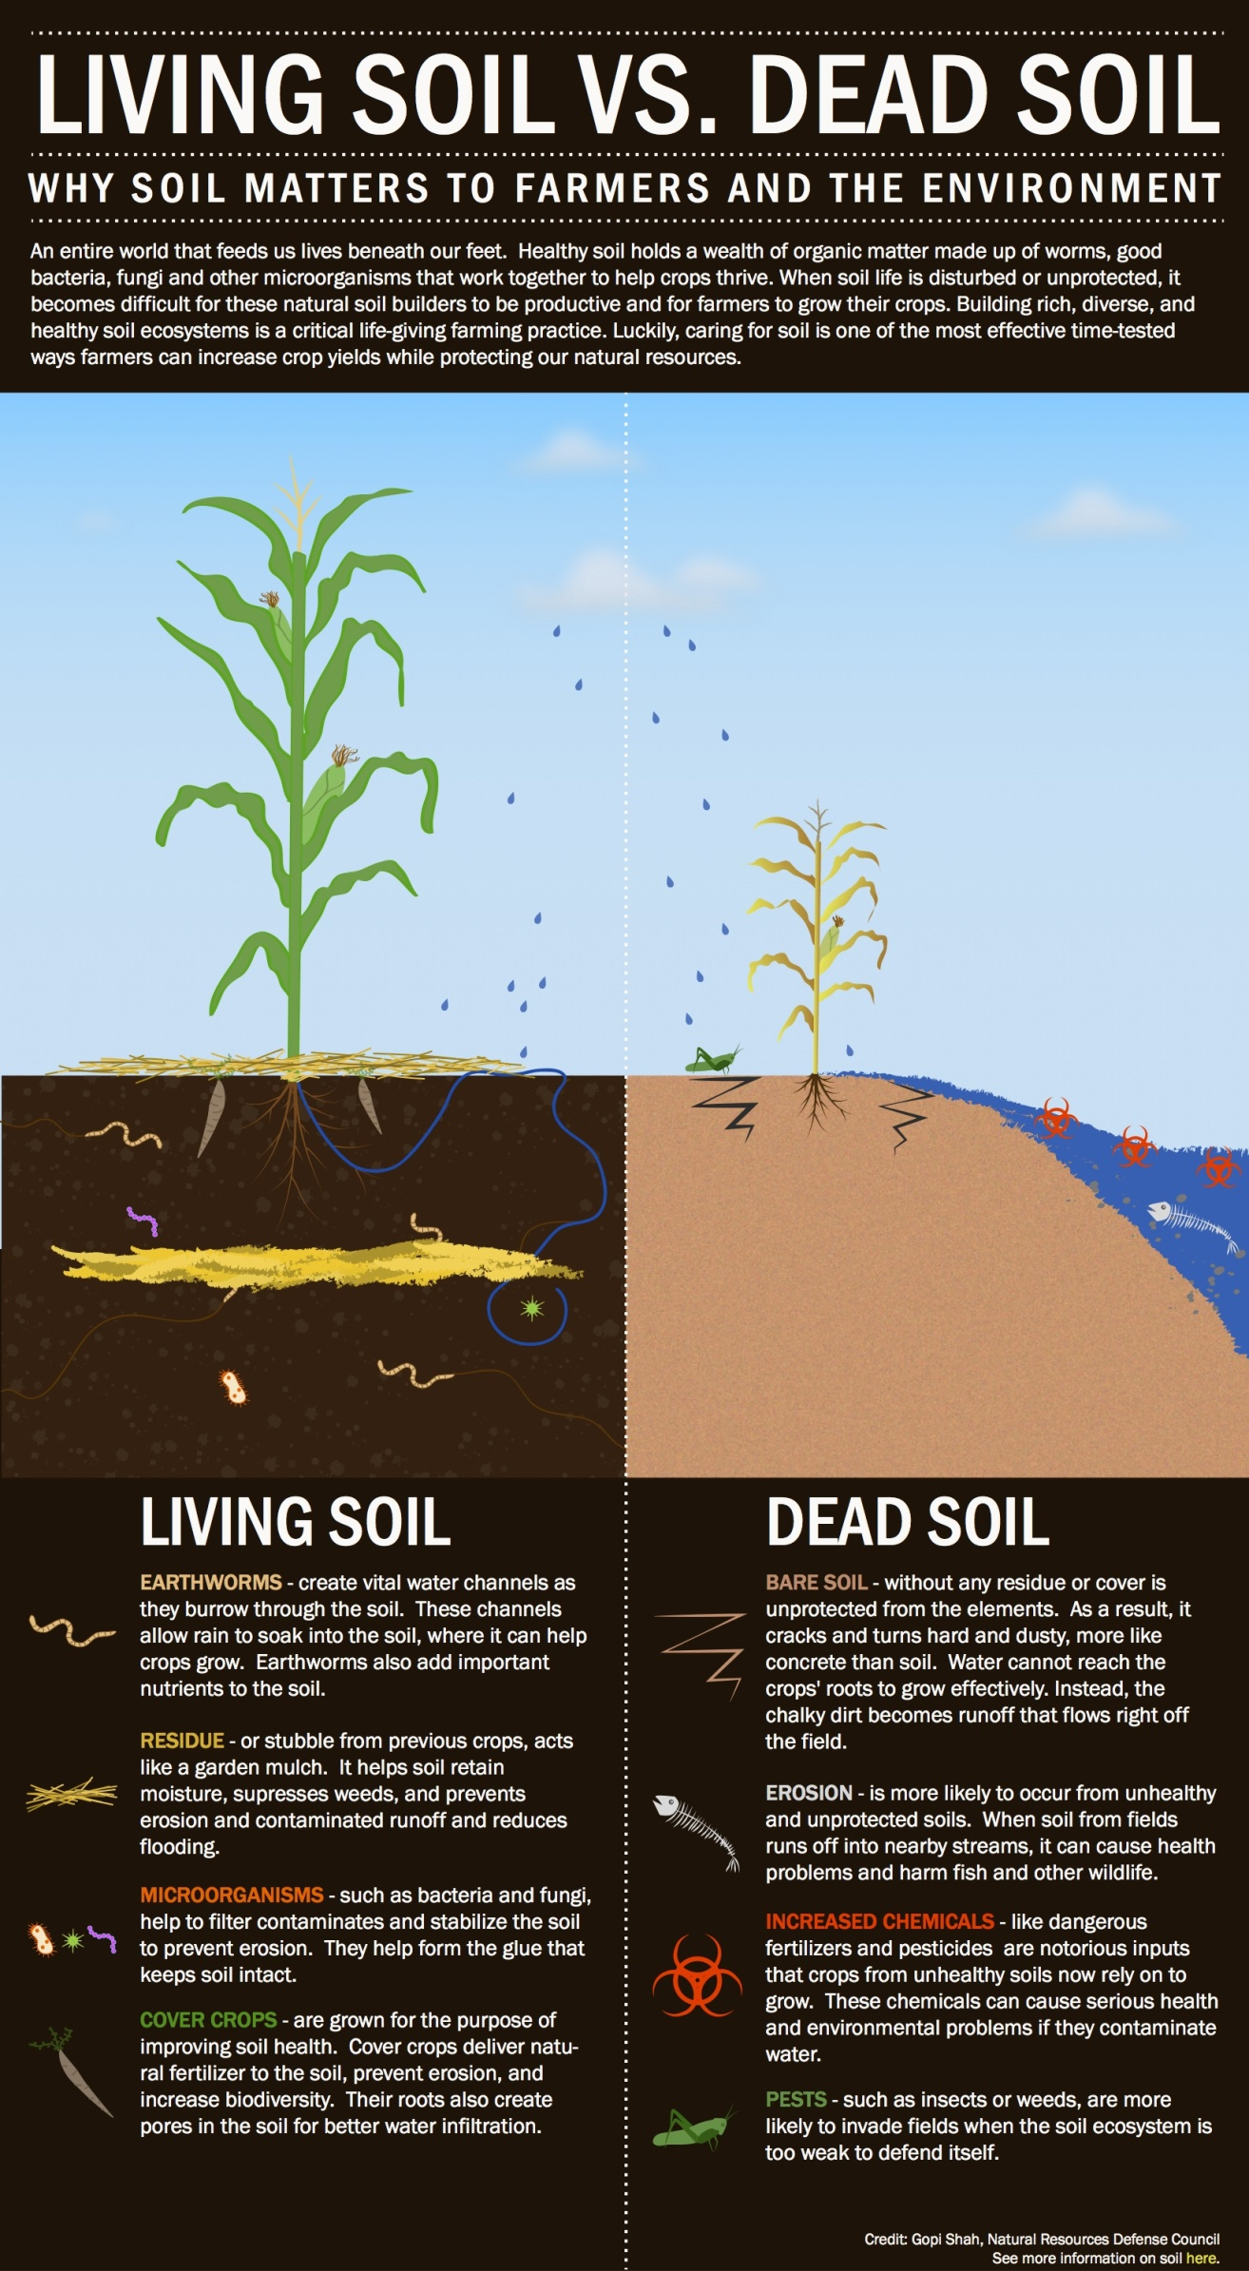

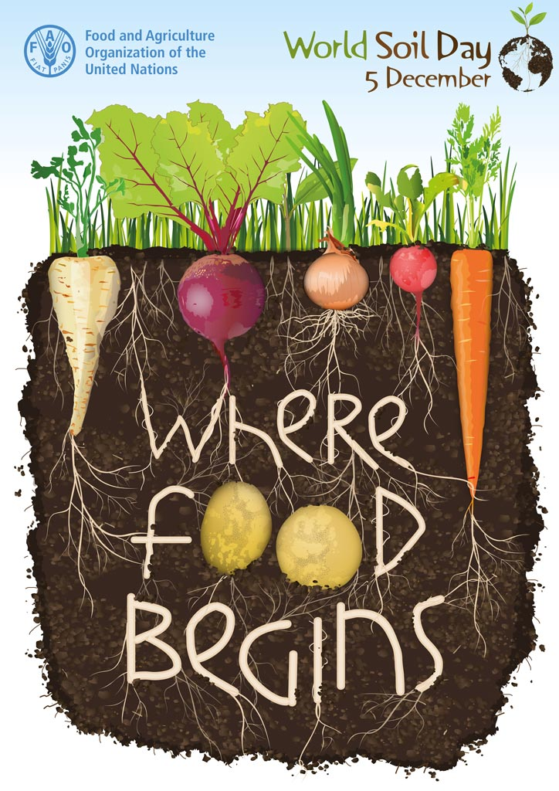

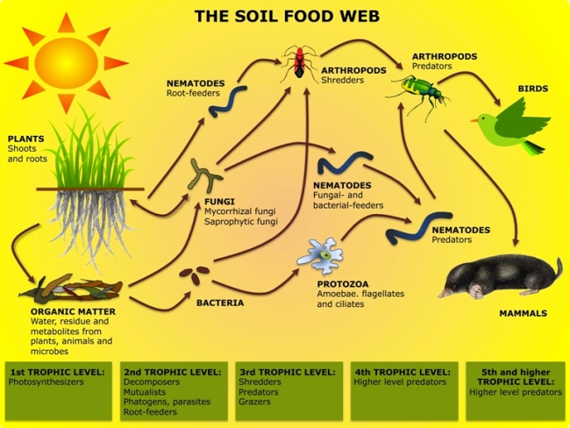

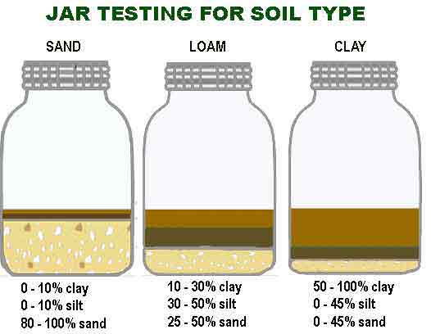

http://gyop.potato.org.uk/media/dynamic-content/documents/worksheets/SEN%20resources/Part%202/21.%20R2%20Movement%20sequence.pdf

Somgs

http://gyop.potato.org.uk/media/dynamic-content/documents/worksheets/SEN%20resources/Part%202/22.%20R3%20songs.pdf

Powerpoint

http://gyop.potato.org.uk/pc143/Teacher-resources/Special-Educational-Needs-SEN

Videohttp://gyop.potato.org.uk/media/files/potatoes.wmv

Images

http://gyop.potato.org.uk/Downloads.aspx?UploadTypeId=4&PageId=83

pow

Assembly ideas