PLANTS LIST 2022
Our plants are distributed to the public through direct sales from our Hawkwood Nursery site, or "Plant Box" home deliveries.
We do accept "bespoke orders" from community project looking to buy large numbers (minimum order £100). In this case we would usually "sow to order", so require 4 weeks' notice. The list below can be used as a stock guide and order form. Prices do not include delivery.

FOR HARVEST IN SUMMER-AUTUMN (available May-June) | Price
Aubergine Black Beauty, Listarda de Gandia | £2
Beans: Climbing french beans: Blauhilde, Neckargold, Borlotti, Cobra, Kew Blue, Cherokee Trail of Tears (1 - 3 plants per pot) | £2
Beans: Dwarf French Beans: Maxi (1 -3 per pot) | £2
Beans: Runner: Scarlet Emperor, Enorma (1-3 per pot) | £2
Companion flowers: Borage , Calendula, Chamomile , Clarkia, Cornflower , Cosmos , Echinacea, Echinops, Gypsophilia , French Marigold, Ice plant, Mexican Sunflower, Monarda, Morning Glory, Nasturtium, Nicotiana, Nigella, Pot Marigold, Pinks, Sweet Pea, Sweet Rocket, Sweet Woodruff, Sunflower, Viola, Wallflower, Zinnia | £2
Courgette (early season): Nero di Milano, Cocozelle, Gold Rush | £2
Cucumber (outdoor): Marketmore, Crystal Lemon, Keera | £2
Globe Artichoke Imperial Star | £2
Kitchen Herbs: Basil (Genovese, Chen, Thai & Red), Bronze Fennel, Chamomile, Chives, Coriander, Dittander, Garlic Chives, Golden Oregano, Horseradish, Leaf Celery, Lemon Balm, Marjoram, Mints - Apple, Pineapple, Pepper, Spear, Parsley (Plain & Curled), Sage, Shiso | £2
Kudu, (Gourds from S. Asia) | £2
Melon Hales Best Jumbo | £2
Peas Meteor, Sugarsnap (3 plants per pot) | £2
Peppers (hot – chilli): Ring of Fire, Cayenne, Hungarian Hot Wax, Jalapeno, Habanero, Scotch Bonnet, Serrano | £2
Peppers (sweet): Long Red Marconi, Albanian | £2
Squash: Butternut, Uchiki Kuri, Fictor, Daughter of Hawkwood, Jack Be Little, Turk Turban, Black Futsu, Jack O Lantern. Musquee de Provence | £2
Sweetcorn: Tramunt (1 - 3 plants per pot) | £2
Tomatoes: Essex Wonder, Carter's Golden Sunrise, Gardener’s Delight, San Marzano, Quadro, Golden Queen, Tigerella, Oxheart, Green Zebra, Yellow Submarine, Paul Robeson, Red Robeson, Darby Striped Yellow/Green, Cherokee Purple | £2
Walthamstow Yellow Cress | £2
SALAD & VEGETABLE PLUGS £4/10
Salad Leaves: 10 plugs summer mixed salad selection, containing a minimum of 2 different leaves from: Amaranth; Bulls Blood Beet; Lettuce - Red or Green Salad Bowl, Cos; Mizuna; Namenia; Wild Rocket; Salad Rocket; Mustard; Perpetual Spinach; Red Orache; Rainbow Chard; Swiss Chard; Chicory; French Sorrel
Vegetable Plant Plugs: Beetroot, Cabbage, Celery, Florence Fennel, Kale, Leek, Tomato

FOR THE FRUIT GARDEN
Blackcurrant Ben Nevis, Ben Lomond | £6
Gooseberry Greenfinch, Hinonmaki Red | £6
Raspberry canes Autumn Bliss | £4
Rhubarb Timperly Early, Glaskin's Perpetual | £4
Strawberry plants Honeoye (early), Cupid (late) | £3.50
Worcesterberries (in the gooseberry family: high yielding large red gooseberries) | £6
COMPOSTS – HAND-MADE AT HAWKWOOD:
Seed compost (20L sack) Organic (Og), peat free (PF), animal free (AF) | £8
Potting-on compost (perfect for transplanting seedlings): 20L/40L (Og, PF, AF) | £8/£14
Container Compost (loam-based for weight & slow release nutrients): 20L/40L(Org, PF, AF) | £11/  £ 20
Garden compost - Soil improver (add before plants go in to a space) 40L (PF, AF) | £6
Wood chip (decorative and biodegradable mulch) 40L | £2
Our plants: We raise all the plants by hand in our Chingford glasshouse. Work is carried out by a team including members of our workers’ cooperative and many volunteers. The plants are grown strong and healthy, not big and sappy - ready to compete effectively with weed seedlings and garden pests! - and are acclimatised to the outdoors before dispatch. We can provide aftercare tips on request, and offer plant packages specifically designed for schools (avoiding summer holiday harvests) or community groups – contact us for more details.
Bulk order discounts: £200+ 5% off; £300+ 10% off; 400+ 15% off; £500+ 20% off
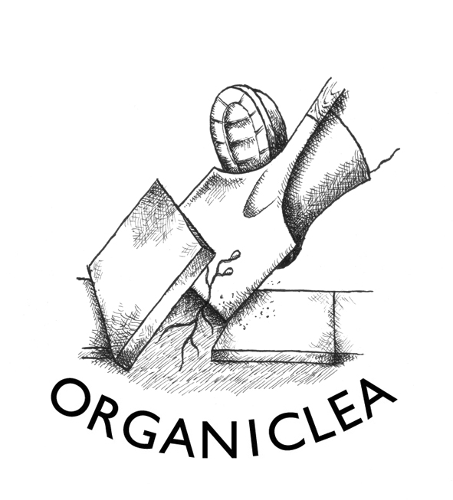
Contact Organiclea’s Hawkwood site to order plants.
Call 020 8524 4994, email plants@organiclea.org.uk, mail to Hawkwood Nursery, 115 Hawkwood Crescent E4 7UH, or bring this order form to the site.

Updated 5 April 2022

