PLANTS LIST & ORDER FORM 2020
Get a helping hand on your plot this growing season with locally grown food plants & compost. You can buy from one of our plant stalls in April-June and August-September 2019 in Northeast London – see www.organiclea.org.uk for dates. Or for bigger quantities place an advance order using this form. As some plants are sown to order, dispatch may take up to four weeks, so we encourage early ordering, but do get in touch if you need to know what is immediately available. Last orders for plants to be placed is 1st April for orders under £100: Last orders for plants totalling over £100: 19th May
FOR HARVEST IN SUMMER-AUTUMN (available May-June) | Price | Quantity
Aubergine Black Beauty, Listarda de Gandia | £1.50
Beans: Climbing french beans: Blauhilde, Neckargold, Borlotti, Cobra, Kew Blue, Cherokee Trail of Tears (2 - 3 plants per pot) | £1.50
Beans: Dwarf French Beans: Maxi (2 -3 per pot) | £1.50
Beans: Runner: Scarlet Emperor, Enorma (2-3 per pot) | £1.50
Companion flowers: Borage , Calendula, Chamomile , Clarkia, Cornflower , Cosmos , Echinacea, Echinops, Gypsophilia , French Marigold, Ice plant, Mexican Sunflower, Monarda, Morning Glory, Nasturtium, Nicotiana, Nigella, Pot Marigold, Pinks, Sweet Pea, Sweet Rocket, Sweet Woodruff, Sunflower, Viola, Wallflower, Zinnia | £1.50
Courgette (early season): Nero di Milano, Cocozelle, Gold Rush | £1.50
Cucumber (outdoor): Marketmore, Crystal Lemon, Keera | £1.50
Globe Artichoke Imperial Star | £1.50
Kitchen Herbs: Basil (Genovese, Chen, Thai & Red), Bronze Fennel, Chamomile, Chives, Coriander, Dittander, Garlic Chives, Golden Oregano, Horseradish, Leaf Celery, Lemon Balm, Marjoram, Mints - Apple, Pineapple, Pepper, Spear, Parsley (Plain & Curled), Sage, Shiso | £1.50
Kudu, (Gourds from S. Asia) | £1.50
Melon Hales Best Jumbo | £1.50
Peas Meteor, Sugarsnap (3 plants per pot) | £1.50
Peppers (hot – chilli): Ring of Fire, Cayenne, Hungarian Hot Wax, Jalapeno, Habanero, Scotch Bonnet, Serrano | £1.50
Peppers (sweet): Long Red Marconi, Albanian | £1.50
Squash: Butternut, Uchiki Kuri, Fictor, Daughter of Hawkwood, Jack Be Little, Turk Turban, Black Futsu, Jack O Lantern. Musquee de Provence | £1.50
Sweetcorn: Tramunt (3 plants per pot) | £1.50
Tomatoes: Essex Wonder, Carter's Golden Sunrise, Gardener’s Delight, San Marzano, Quadro, Golden Queen, Tigerella, Oxheart, Green Zebra, Yellow Submarine, Paul Robeson, Red Robeson, Darby Striped Yellow/Green, Cherokee Purple | £1.50
Walthamstow Yellow Cress | £1.50
SALAD & VEGETABLE PLUGS | £3 for 10
Salad Leaves: 10 plugs summer mixed salad selection, containing 5 different leaves from: Amaranth; Bulls Blood Beet; Lettuce - Red or Green Salad Bowl, Cos; Mizuna; Namenia; Wild Rocket; Salad Rocket; Mustard; Perpetual Spinach; Red Orache; Rainbow Chard; Swiss Chard; Chicory; French Sorrel
Vegetable Plant Plugs: Beetroot, Cabbage, Celery, Florence Fennel, Kale, Leek, Tomato
FOR GROWING/ HARVEST IN WINTER (available in August/ September)
10 plug mixed winter selection, containing 5 different leaves from: Bulls Blood Beet; Lettuce - Brun d’Hiver; Endive; Mizuna; Namenia; Wild Rocket; Salad Rocket; Mustard; Land Cress; Watercress; Red Russian Kale; Perpetual Spinach; Rainbow Chard; Swiss Chard; Chicory; French Sorrel; Lambs Lettuce; Chervil
Mixed Green Manures
Broad Beans, Peas (3 per pot)

FOR THE FRUIT GARDEN
Blackcurrant Ben Nevis, Ben Lomond | £4.50
Gooseberry Greenfinch, Hinonmaki Red | £4.50
Raspberry canes Autumn Bliss | £3
Rhubarb Timperly Early, Glaskin's Perpetual | £3
Strawberry plants Honeoye (early), Cupid (late) | £2.50
Worcesterberries (in the gooseberry family: high yielding large red gooseberries) | £4.50
COMPOSTS – HAND-MADE AT HAWKWOOD:
Seed compost (20L sack) Organic (Og), peat free (PF), animal free (AF) | £6
Potting-on compost (perfect for transplanting seedlings): 20L/40L (Og, PF, AF) | £6/£10
Container Compost (loam-based for weight & slow release nutrients): 20L/40L(Org, PF, AF) | £8/£15
Garden compost - Soil improver (add before plants go in to a space) 40L (PF, AF) | £5
Wood chip (decorative and biodegradable mulch) 40L | £2
Please use this form to place your order (minimum order is 5 plants; for less please come to one of our stalls). You can underline your particular choice of variety if you have a preference. Please note that the list here is all subject to availability – some plant types and varieties will be ready at different stages of the season, so let us know whether you are happy to accept substitutions (always of the same species/category).
Name:
Tel number: | Email:
Substitutions: Please tick if you are happy to accept substitutes if your choice is not available | I’m happy to receive a different variety YES/NO  I’m happy to receive a different plant YES/NO
Amount to pay: | £ | PAID:
Collection details: | Preferred date for collection: | Preferred location (Hawkwood or Hornbeam):
Our plants: We raise all the plants by hand in our Chingford glasshouse. Work is carried out by a team including members of our workers’ cooperative and many volunteers. The plants are grown strong and healthy, not big and sappy - ready to compete effectively with weed seedlings and garden pests! - and are acclimatised to the outdoors before dispatch. We can provide aftercare tips on request, and offer plant packages specifically designed for schools (avoiding summer holiday harvests) or community groups – contact us for more details.
Delivery: We may be able to bring plants to the Hornbeam Centre, 458 Hoe St, E17 9AH for a more central collection point. And we may be able to deliver larger orders (over £50) direct, cost for delivery (to cover fuel and driver costs) from £15 depending on distance.
Bulk order discounts: £200+ 5% off; £300+ 10% off; 400+ 15% off; £500+ 20% off
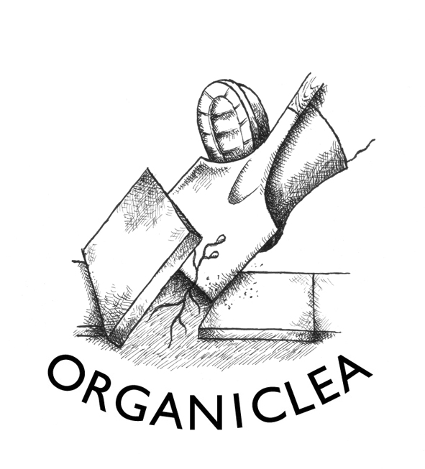
Contact Organiclea’s Hawkwood site to order plants.
Call 020 8524 4994, email plants@organiclea.org.uk, mail to Hawkwood Nursery, 115 Hawkwood Crescent E4 7UH, or bring this order form to the site.

Updated 2 March 2018

