PLANTS LIST & ORDER FORM 2017
Get a helping hand on your plot this growing season with locally grown food plants & compost. You can buy from one of our plant stalls in April-June and August-September 2017 in Northeast London – see www.organiclea.org.uk for dates. Or place an advance order using this form. As some plants are sown to order, dispatch may take up to four weeks, so we encourage early ordering, but do get in touch if you need to know what is immediately available.

FOR HARVEST IN SUMMER-AUTUMN (available May-June) | Price | Quantity
Aubergine Black Beauty | £1.50
Beans: Climbing french beans: Kew Blue, Neckargold, Borlotti, Cobra (2 - 3 plants per pot) | £1.50
Beans: Dwarf French Beans: Speedy, Borlotti, (2 -3 per pot) | £1.50
Beans: Runner: Scarlet Emperor (2-3 per pot) | £1.50
Cape Gooseberry | £1.50
Companion flowers: French Marigold, Pot Marigold, Borage, Echinacea, Cornflower, Nasturtium, California poppy, Breadseed Poppy, Nigella, Sunflower, Hollyhock, Cosmos, Morning Glory, Viola, Sweet Pea, Viola, Milk Thistle, Sweet Rocket, Chamomile, Echinops, Pinks, | £1.50
Courgette (early season): Nero di Milano, Cocozelle, Zuboda | £1.50
Cucumber (outdoor): Marketmore, Crystal Lemon, Keera, Parisian Pickling | £1.50
Globe Artichoke Imperial Star | £1.50
Kitchen Herbs: Basil (Genovese, Chen, Thai & Red), Chives, Parsley (Plain & Curled), Spearmint, Peppermint, Apple Mint, Lemon Balm, Leaf Celery, Bronze Fennel, Coriander, Sage, Shiso | £1.50
Kudu, Loki (Gourds from S. Asia) | £1.50
Melon Hales Best Jumbo | £1.50
Peas Meteor, Rondo, Sugarsnap (3 plants per pot) | £1.50
Peppers (hot – chilli): Ring of Fire, Cayenne, Hungarian Hot Wax, Jalapeno, Habanero, Scotch Bonnet, Tabasco, Serrano | £1.50
Peppers (sweet): Long Red Marconi, Californian Wonder | £1.50
Squash: Butternut, Uchiki Kuri, Cinderella, Jack Be Little, Turk Turban, Retzer Gold, Buttercup, Sweet Dumpling, Green Kabocha, Jack O Lantern | £1.50
Sweetcorn: Golden Bantam, Aztec Rainbow, Tramund (3 plants per pot) | £1.50
Tomatoes: Gardener’s Delight, Koralik, San Marzano, Tumbling Tom, Quadro, Golden Queen, Tigerella, Oxheart, Green Zebra | £1.50
Walthamstow Yellow Cress | £1.50
SALAD & VEGETABLE PLUGS | £3 for 10
Salad Leaves: 10 plugs summer mixed salad selection, containing 5 different leaves from: Amaranth; Bulls Blood Beet; Lettuce - Red or Green Salad Bowl, Cos; Mizuna; Namenia; Wild Rocket; Salad Rocket; Mustard; Perpetual Spinach; Red Orache; Rainbow Chard; Swiss Chard; Chicory; French Sorrel
Vegetable Plant Plugs: Beetroot, Cabbage, Celery, Florence Fennel, Kale, Leek, Tomato
FOR GROWING/ HARVEST IN WINTER (available in August/ September)
10 plug mixed winter selection, containing 5 different leaves from: Bulls Blood Beet; Lettuce - Brun d’Hiver; Endive; Mizuna; Namenia; Wild Rocket; Salad Rocket; Mustard; Land Cress; Watercress; Red Russian Kale; Perpetual Spinach; Rainbow Chard; Swiss Chard; Chicory; French Sorrel; Lambs Lettuce; Chervil
Mixed Green Manures
Broad Beans, Peas (3 per pot)

FOR THE FRUIT GARDEN
Blackcurrant Ben Nevis, Ben Lomond | £4.50
Fig White Marseilles | £6.50
Gooseberry Invicta, Leveller, Hinomaki | £4.50
Grape vines Pinot Noir, Regent | £6.50
Jostaberry | £4.50
Loganberry Thornless | £4.50
Raspberry canes Autumn Bliss | £3
Rhubarb Timperly Early | £3
Strawberry plants Cupid (late), Honeoye (early) AVAILABLE FROM SEPTEMBER | £2.50
Worcesterberries (in the gooseberry family: high yielding large red gooseberries) | £4.50
Apple trees – contact us for variety and size details | £10
COMPOSTS – HAND-MADE AT HAWKWOOD:
Seed compost (20L sack) Organic (Og), peat free (PF), animal free (AF) | £6
Potting-on compost (perfect for transplanting seedlings): 20L/40L (Og, PF, AF) | £6/£10
Garden compost - Soil improver (add before plants go in to a space) 40L (PF) | £5
Wood chip (decorative and biodegradable mulch) 40L | £2
Please use this form to place your order. You can underline your particular choice of variety if you have a preference. Please note that the list here is all subject to availability – some plant types and varieties will be ready at different stages of the season, so let us know whether you are happy to accept substitutions (always of the same species/category).
Name:
Tel number: | Email:
Substitutions: Please tick if you are happy to accept substitutes if your choice is not available | I’m happy to receive a different variety YES/NO  I’m happy to receive a different plant YES/NO
Amount to pay: | £ | PAID:
Collection details: | Date for collection: | Location:
Our plants: We raise all the plants by hand in our Chingford glasshouse. Work is carried out by a team including members of our workers’ cooperative and many volunteers. The plants are grown strong and healthy, not big and sappy - ready to compete effectively with weed seedlings and garden pests! - and are acclimatised to the outdoors before dispatch. We can provide aftercare tips on request, and offer plant packages specifically designed for schools (avoiding summer holiday harvests) or community groups – contact us for more details.
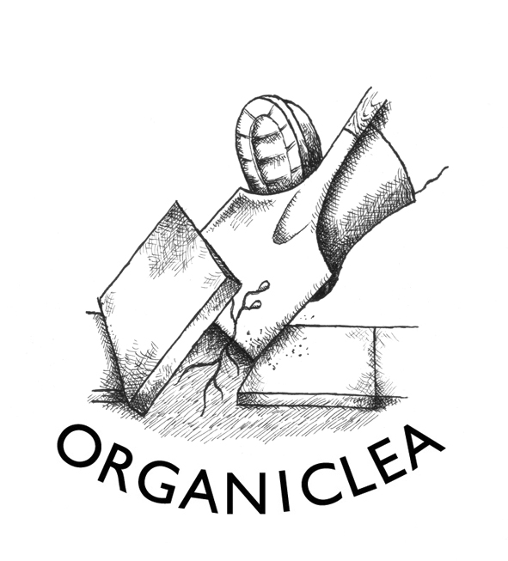
Delivery: We can bring plants to the Hornbeam Centre, 458 Hoe St, E17 9AH for a more central collection point. We may be able to deliver larger orders direct to you. Cost for delivery (to cover fuel and driver costs) from £15 depending on distance.
Bulk order discounts: £200+ 5% off; £300+ 10% off; 400+ 15% off; £500+ 20% off
Contact Organiclea’s Hawkwood site to order plants.
Call 020 8524 4994, email plants@organiclea.org.uk, mail to Hawkwood Nursery, 115 Hawkwood Crescent E4 7UH, or bring this order form to the site.
Updated 8 March 2016

