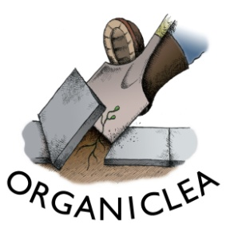
OrganicLea Recruitment - Application Form

1. Contact details
Name:
Address:
Email:
Telephone:

2. Your interest in this role
Please write a brief statement explaining why you are interested in this role including:
a) what experience and skills you can bring to the role, including how you meet the person specification;
b) why you are interested in working for OrganicLea workers’ co-operative.
Please write a maximum of 1000 words.

3. Your work history
Please provide details of your paid and unpaid work history, including the month/year you started and finished each role, and the key responsibilities in it. You can copy this from your CV if you wish.

4. Your training and education
Please provide details of any relevant training or education including dates and qualifications achieved. You can copy this from your CV if you wish.

Other information we will request for successful candidates
Depending on the role we are recruiting for, we may need to ask for information on any unspent convictions, or to make a job offer conditional on an enhanced disclosure and barring check if the role involves working with children or vulnerable adults, or teaching. This will be made clear in the job application pack. We have a commitment to rehabilitation and any convictions disclosed will be considered on a case by case basis.
If you are offered a position it will be an offer subject to references, so we will ask you to provide the name and contact details of two referees.
Please email your application form to Orla O’Flanagan: orla@organiclea.org.uk

Data Protection
Organiclea takes care to ensure that we use your information in accordance with all applicable laws concerning the protection of personal information. Please see more details at https://www.organiclea.org.uk/about/privacy-notice/

