OrganicLea

Job Description

1. JOB DETAILS

Title: Training Team Administrator

Location: Hawkwood Plant Nursery
Hawkwood Crescent
Chingford E4 7UH

Responsible to: Training Team and Distribution team

Hours per Week: 25

Annual Salary: £8.20/hour - £10660 / PA pro rata

Contract: Six Months Fixed Term
- JOB PURPOSE

We are a busy office from which many members of OrganicLea work. The main aim of the job is to provide administration support to the training team to manage the paperwork and data for the course curriculum

3. MAIN DUTIES AND RESPONSIBILITIES

3.1 Respond to enquiries about courses and maintain a database of new and existing students. – Updating and entering data onto excel spreadsheets

3.2 Support the assessment and enrolment process and help upload completed paperwork to online platforms. – Scanning and helping check files enrolment forms both digitally and hard copies

3.3 Help to register learners with awarding bodies and organise and send out certificates

3.4 Collate learner evaluations and progressions

3.5 Help with promotion and marketing of OrganicLea’s variety of courses and taster days

3.6 Attend team meetings

3.7 To take reasonable care for the health and safety of self and others who may be affected by acts or omissions related to your work. Co-operate fully with the management of the Company with regard to any duty or requirement imposed on them by the relevant Health and Safety legislation to allow that duty or requirement to be carried out or complied with.

3.3 Any other reasonable duties and responsibilities considered appropriate by the management of the Company.

- QUALIFICATIONS AND / OR EXPERIENCE REQUIRED

Essential:

- ITC – Able to effectively use email, word, spreadsheets
- Able to communicate well both verbally and written with a good standard of English
- Organised with an attention to detail

Desirable:
- An interest in working in a cooperative and food growing
- Keen to share ideas and use initiative

Please Note:
These duties defined in this Job Description are not definitive and may be subject to future amendments following appropriate consultation.

Approved By:

Signature: ______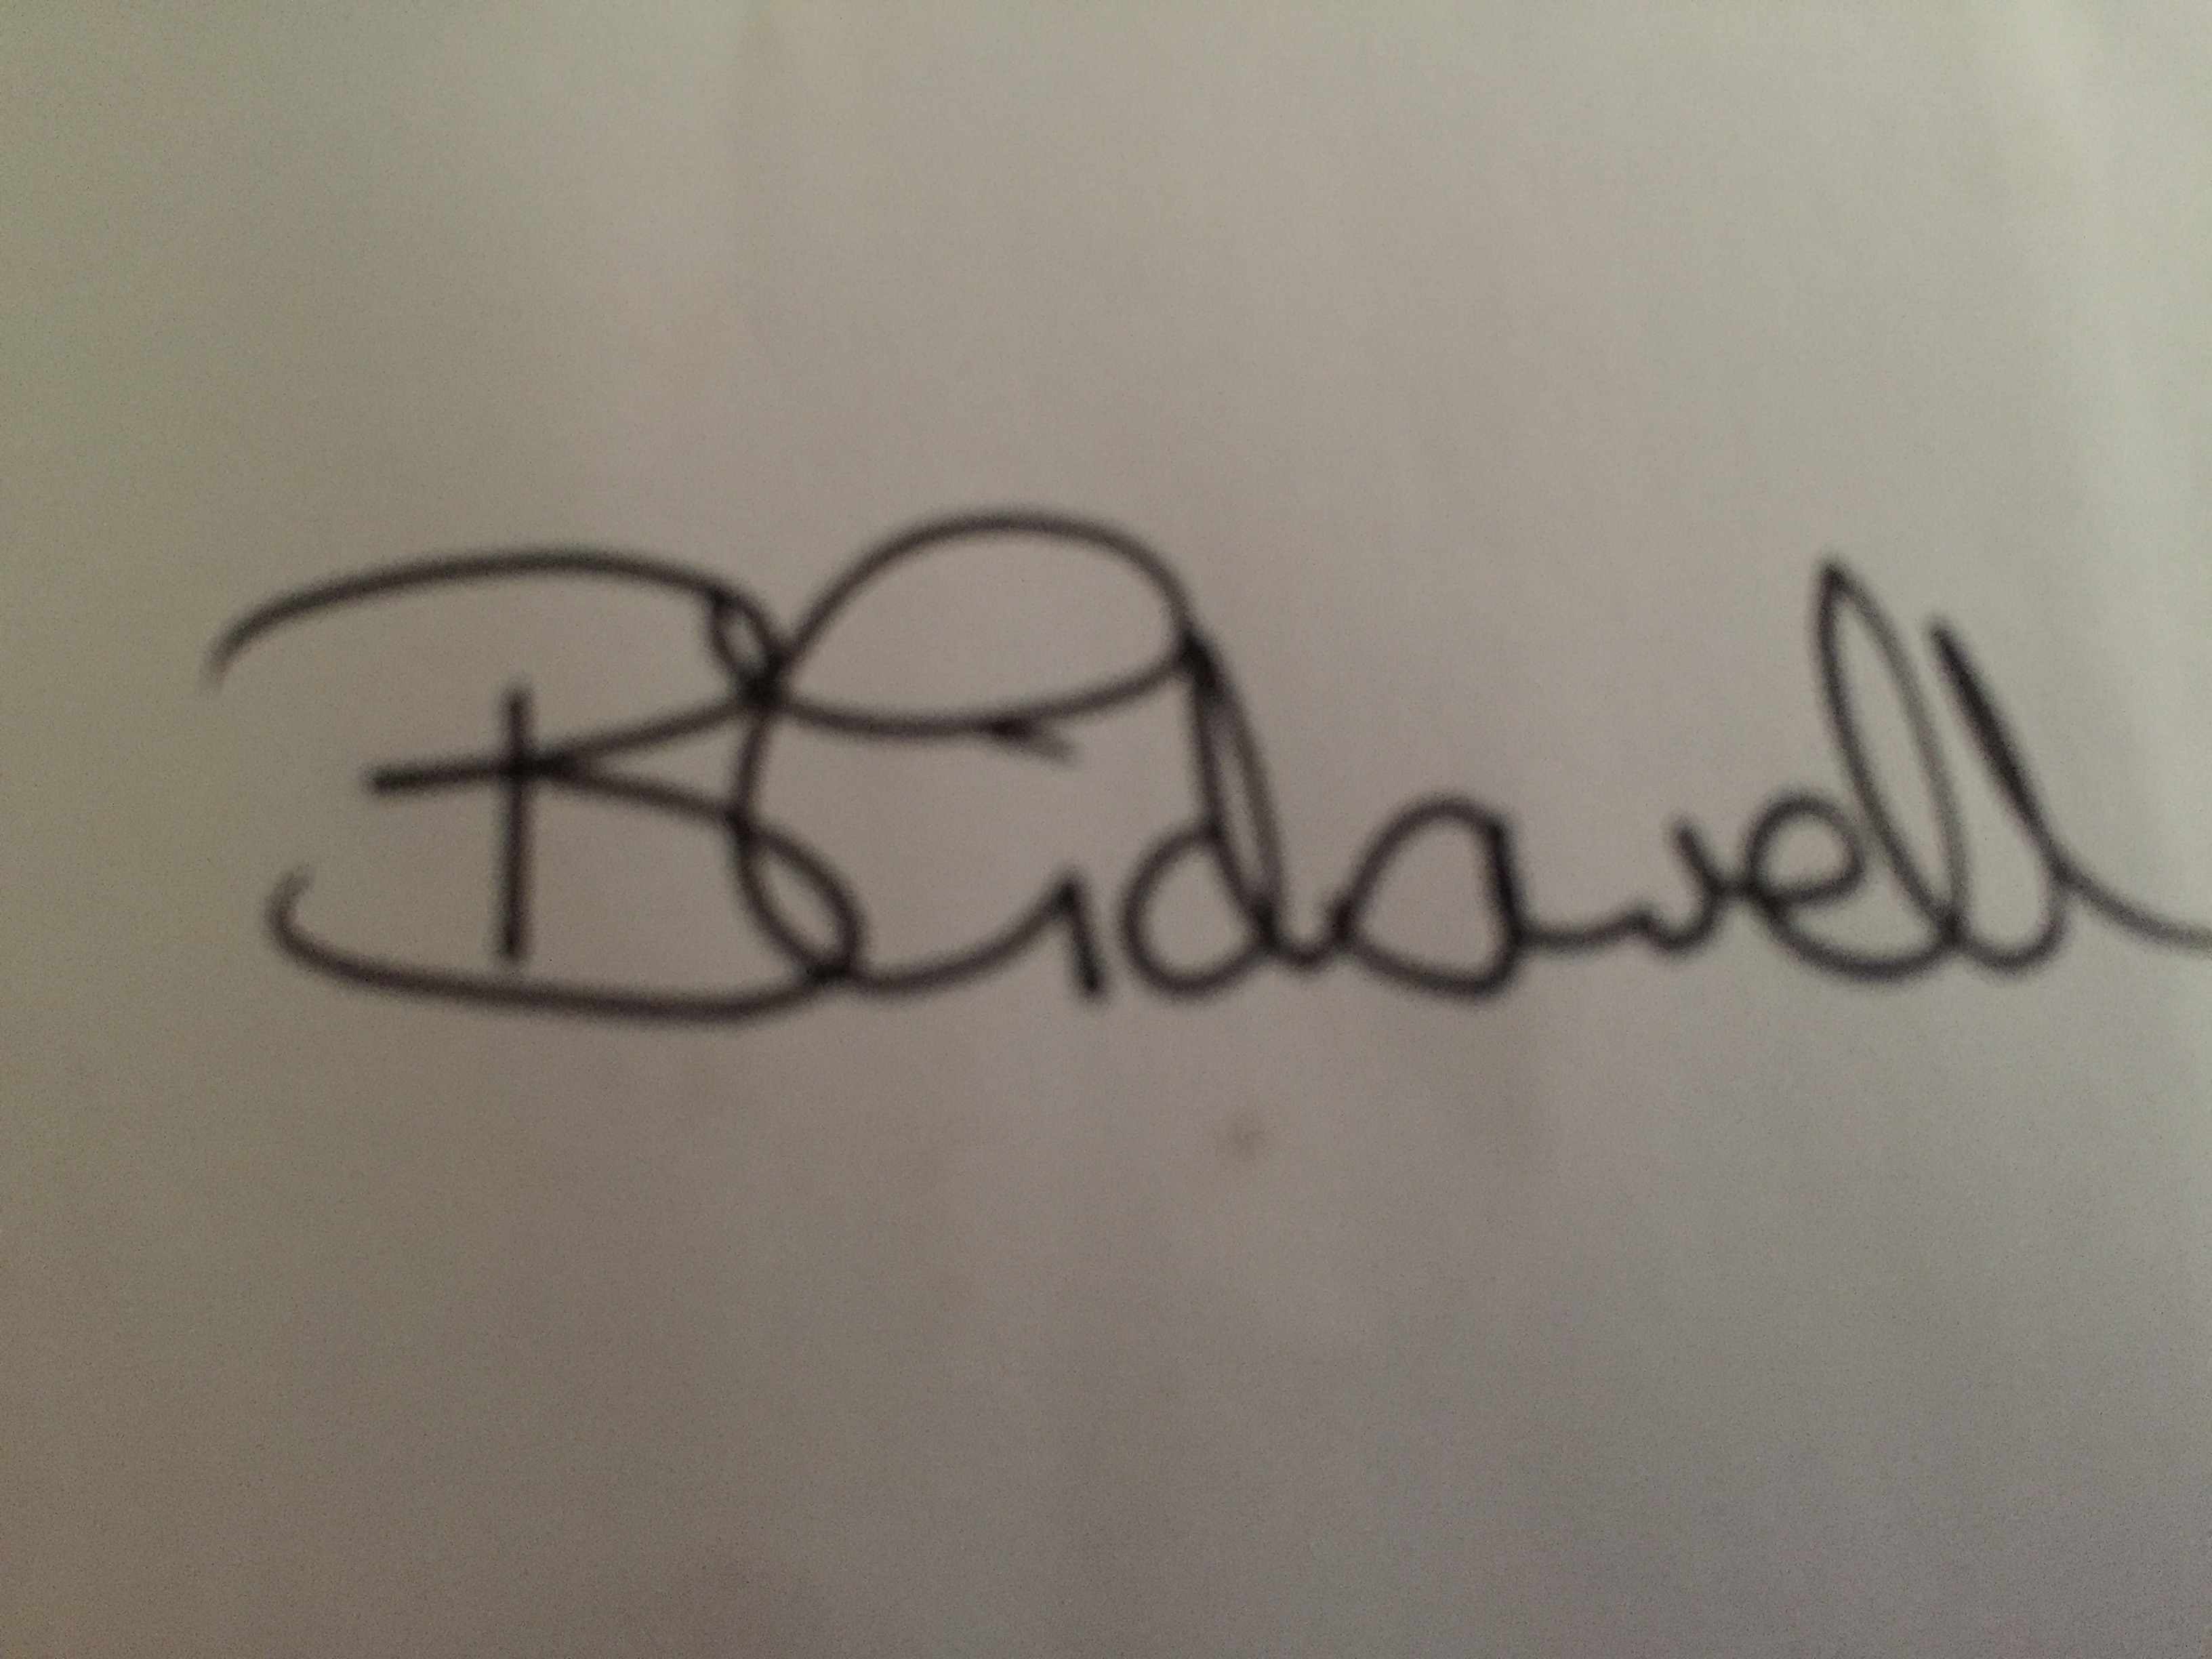

Print Name: ______Belle Tidswell____________________________________________

Date: 15.10.20

