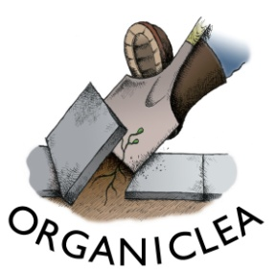
Produce Co-ordinator & Comms: How to Apply
Please read the job description and person specification carefully before providing the details below.
1. Contact details
Name:
Address:
Email:
Telephone:

2. Your interest in this role
Please write a maximum of 1000 words.
Please write a brief statement explaining why you are interested in this role including:
a) what experience and skills you can bring to the role, including how you meet the person specification;
b) why you are interested in becoming part of OrganicLea workers’ co-operative (please note that, as this is a maternity cover role, this is not a co-op member role).

3. Your work history
Please provide details of your paid and unpaid work history, including the month/year you started and finished each role, and the key responsibilities in it. You can copy this from your CV if you wish.

4. Your training and education
Please provide details of any relevant training or education including dates and qualifications achieved. You can copy this from your CV if you wish.

5. How did you hear about this role?
This helps us monitor our recruitment and advertising.

6. Disability Confident - adjustments to interview and guaranteed interviews
We are committed to becoming a fully Disability Confident employer. Please let us know if you have a disability, consider that you meet the essential criteria for the role and would like a guaranteed interview. Please also advise of any reasonable adjustments you require during the recruitment process. You do not need to provide any details of your disability at this stage. If you prefer to have a telephone conversation about this rather than putting details on the form, please simply provide a contact number here.

Other information we will request for successful candidates
Depending on the role we are recruiting for, we may need to ask for information on any unspent convictions or a basic Disclosure & Barring Service (DBS) check, or to make a job offer conditional on an enhanced DBS check if the role involves working with children or vulnerable adults, or teaching. This will be made clear in the job description document. We have a commitment to rehabilitation and any convictions disclosed will be considered on a case by case basis.
If you are offered a position it will be an offer subject to references, so we will ask you to provide the name and contact details of two referees.

We are also required by law to confirm eligibility to work in the UK through passport, residence permit or immigration documents.

Please send completed applications to tsouni@organiclea.org.uk
Deadline for applications is 1pm on Monday 27th September
Interviews scheduled for Monday 4th October.
Start date: Monday 8th November.

Data Protection
Organiclea takes care to ensure that we use your information in accordance with all applicable laws concerning the protection of personal information. Please see more details at https://www.organiclea.org.uk/about/privacy-notice/

