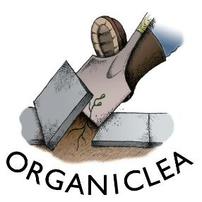
Volunteer Role Description
Health and Wellbeing Activities Support, Tuesdays (1 post)

At Organiclea we believe in people and permaculture, growing food and people on site and in the wider community. Our diverse volunteering programme includes a Health & Wellbeing programme to develop participant’s understanding of wellness, recovery and to reduce medical interventions.
This 12-week volunteer placement is a new opportunity - based mainly at the Hawkwood site in Chingford, but with opportunity to experience (an)other projects organised with OrganicLea's community outreach gardens team. Your work will be principally with the Health & Wellbeing placement worker who is developing a new programme of weekly activities aimed at recovery and green space connection on Tuesday afternoons at the Hawkwood site. Some flexibility around the committed day will allow the integration with community outreach projects - where activities can sometimes be on other half days.

Details of the role
- Volunteer position.
- 1 day a week for minimum 12 weeks.
- Commencing Tuesday 28 January,to be complete by the end of April 2020.
- Hours: Tuesdays 9.15am - 5.00pm.
- Based at Hawkwood Community Plant Nursery.
Occasional additional days or shift in regular weekly day for additional work experience with the outreach gardens team. To be developed later in the placement.

Main objectives
- Assist with the development of Hawkwood as a site for recovery and green space connection.
- Assist with the delivery of health & wellbeing programmes on and off site at Hawkwood (or in the local community).

Main Duties
- Assist Health & Wellbeing Placement Worker to deliver a regular programme of activities to support wellness and recovery (working with volunteers who are neurodiverse, experiencing mental ill health, physical difficulties or language barriers).
- Assist Engagement Coordinator and Community Growing team to identify and engage with people who are likely to benefit from the health & wellbeing programme.
- Meeting, greeting and orienting participants.
- Assisting participants with completion of data gathering and monitoring forms.
Person Specification
Essential
- Desire to support and empower others to manage their own health & wellbeing.
- Patient and empathic.
- Flexible and adaptable to change.
- Understanding of issues surrounding Safeguarding, Health and Safety.
- Commitment to Diversity and Inclusion.
- Commitment to and understanding of Organiclea’s values and aims.

Desirable
- Experience of working with neurodiverse adults and those experiencing or recovering from ill mental health.
- Experience of delivering workshops and support groups.

To register interest. Please contact natasha@organiclea.org.uk by Monday 20 January. Please include a telephone number you can be reached on.
Proposed induction into role and start date is Tuesday 28 January.

