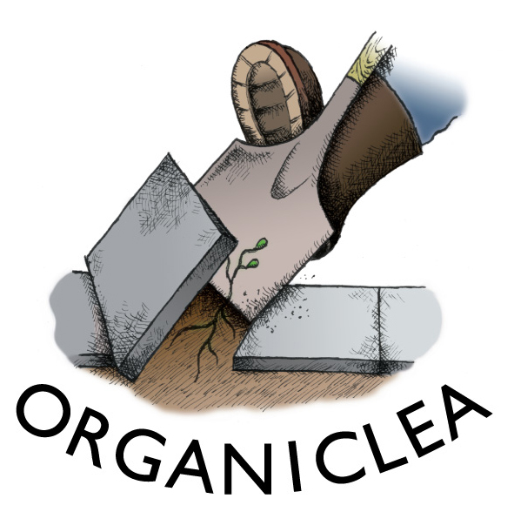

**Job opportunity:**

**Green Influencers Youth Worker Role (3 days per week)**

**Are you interested in encouraging Youth Social Action projects in Waltham Forest?** Organiclea has received funding to employ an experienced and enthusiastic youth leader to engage and motivate groups of young people in social action projects of their own choosing. With your encouragement, groups of young people aged between 10 and 14 years old (Green Influencers) will engage with their peers and others in their local community and lead on environmental action projects.

**If you have relevant experience in youth work, and the desire to empower young people to lead on environmental social action projects, we want to hear from you.**

This role is match funded by The Ernest Cook Trust and #iwill, to create on average six Green Influencer groups per year, strategically plan and be part of fundraising for the future beyond the 2.5 years of confirmed funding, and to be part of our worker’s cooperative. This role is part of our Community Growing and Young People’s team. It requires a person who is excellent at communicating and strategising; and wants be an active part of a team committed to encouraging projects to overlap and influence each other, whilst utilising existing and new networks and connections.

This role will involve ongoing strategic partnership with Waltham Forest council, educator networks, youth groups, schools, and connections made through Organiclea’s Community Growing projects.

More detailed tasks and responsibilities, and the skills and qualities we are seeking, are set out below. Experience of working with and within diverse communities and an understanding of and willingness to develop and co-create projects alongside young people is more important than formal education.

If you do not meet all the skills and experience listed in the personal specifications, but feel you are the right person for some of this work, you are still encouraged to apply. 

**General Co-op responsibilities:**

OrganicLea is a workers’ co-operative (currently 24 coop members in paid contracted roles) whose activities are managed by its members. We are recruiting for a coop member with this role, so you need to be able to contribute to OrganicLea’s governance and strategic development which can involve occasional paid and unpaid work in addition to your role hours. These include:

* Participate in General Meetings and work teams of the cooperative and support the processes of consensus decision-making within the cooperative.
* All workers are required to monitor and mitigate financial, health and safety and other risks within their area of responsibility.
* Share responsibility for peer appraisal and support, facilitating meetings, minute-taking, and other organisation-wide tasks.
* Participate in the organisational development of OrganicLea, including contributing to the development of other related projects within the cooperative.
* Work together with other Co-op members and volunteers according to co-operative and permaculture principles (for information see organiclea.org.uk)

Members are expected to abide by the Secondary Rules and policies of OrganicLea, work considerately and respectfully with all, and be willing to undergo training as deemed appropriate by the Co-op.

**Green Influencers Youth Worker Role**

**Purpose of this role:**

•Build on and add to Organiclea’s existing network of organisations, charities, groups and institutions that support young people and are looking to enable environmental action through youth empowerment.

•Facilitate the creation of approximately six groups of Green Influencers each year.

•Facilitate the groups of Green Influencers in the conception, planning, delivery and continuation of green action projects of their choosing.

•Support local networks in communicating and embedding environmental change beyond the life of the projects.

•Be an active member of a regional and national community of Green Mentors.

**Role responsibilities and tasks:**

Supporting Green Influencers to deliver inspiring projects

• Recruit and motivate a diverse range of young people from the local community (through schools/youth groups/other community forums) to form Green Influencers groups.

•·Enable the groups to engage with their local community and other young people and to design environmental action projects with a clear plan for funding, delivery and evaluation.

• Support the groups in building a network of local stakeholders to ensure projects are embedded in the local community, and build links between Organiclea’s and partner’s existing projects and community groups, and Green Influencer groups.

• Work flexibly within the COVID-19 context and have the ability, or willingness to learn, to work in a ‘blended’ way

• Support Green Influencers to deliver their projects to engage their community, build momentum and share their successes.

• Work within Community Growing and Young People team with a view to sharing information with fellow team members, encourage overlap of projects and delivery wherever possible to strengthen connections across the team, such as sharing ideas, project deliverables, networking opportunities, and more. This team is recently formed and requires someone who shares our commitment to working in cooperation with each other, building on each other’s strengths and promoting healthy interdependence within our team and with other teams at Organiclea.

• Research and develop funding opportunities to sustain the work of Green Influencers beyond the 2.5 year project remit.

Creating a network of community partners

• Identify local organisations that work with and support young adults.

• Create opportunities for Green Influencers to build their own networks.

• Act as a link between groups and community partners to build ongoing support for projects and groups.

Evaluating, communicating and sharing the project outcomes

• Ensure evaluation is embedded into each Green Influencers project.

• Report on project outcomes and evaluation data.

• Work with the ECT Green Influencers Project Coordinator to ensure projects meet funding criteria and are administered in-line with due diligence guidance.

• Actively communicate the work of the Green Influencers groups both regionally and nationally through the wider project network.

Build local and regional momentum for environmental action

• Share best practice and lessons learnt with the wider network of Green Mentors, Community Growing and Young People team members, and the wider co-op where relevant.

• Support Green Influencers to continue environmental action beyond their initial project, identifying further funding, partners or opportunities.

• Where possible, link with other Green Mentors at a regional level to create a network of influencers and mentors.

• Attend national training to further develop professional skills that expand the range and impact of local activity.

**Person Specifications:**

E=Essential criteria D=Desirable criteria

Knowledge

* Good knowledge of youth organisations and networks, ideally informed by a knowledge and understanding of communities in Waltham Forest and neighbouring boroughs (E)
* Good knowledge of youth engagement and motivation techniques (E)
* Good understanding of health and safety and safeguarding practices in an outdoor setting (E)
* Experience in evaluating learning experiences and outcomes (D)
* Experience in budget management, managing grant applications and writing funding bids (D)
* Knowledge of environmental education sector (D)

Skills and Experience

* Working in a youth engagement or youth work setting (E)
* Organising outdoor visits and resources (E)
* Writing risk assessments and safety procedure documents (E)
* Ability to support and engage young people (E)
* Good team work and communications skills (E)
* Interest and enthusiasm for working within a worker’s cooperative (E)
* Experience of working in partnership with a range of community organisations, businesses and local authorities (D)
* Experience of working in a community food project (D)
* Experience of designing, delivering and evaluating campaign or social action projects (D)
* Good IT skills including Office programmes, databases and social media (D)

Qualifications

• Youthwork qualification, coaching/mentoring qualification or equivalent experience (D)

• Outdoor first aid (Minimum 16hrs) (E) (training provided if necessary)

• Management or coaching training (D)

**General**

* Satisfactory enhanced DBS disclosure, or willingness to have an Enhanced DBS check carried out through Organiclea if needed
* Open to flexible working
* Empathy with the aims and values of The Ernest Cook Trust and #iwill and the values and vision of Organiclea.

**The detail:**

* **Hours:** The role is for 3 days per week, with some flexibility around working days. There is likely to be occasional weekend work involved.
* **Salary:** £25,480 per annum pro rata (based on a 35 hour week)
* **Contract length:** This is a permanent contract subject to a 7 month probationary period for coop membership. This role is match funded by #iwill and Ernest Cook Trust for 2.5 years, so after this period the role will need to evolve to fit future funding.
* **Responsible to:** OrganicLea Workers’ Cooperative
* **Location:** The base for project administration can be Hawkwood Community Plant Nursery and at our office at the Hornbeam Centre in Walthamstow.

 Successful appointment to the role will be subject to satisfactory references and will require a Disclosure and Barring service disclosure.

We particularly welcome applications from people with disabilities, BAME community members, LGBTQIA+ people and people without university degrees. We have a commitment to become a Disability Confident employer.

**How to apply:**

* Please read the above role responsibilities and person specification carefully.
* Please follow separate ‘How to apply’ document for information on how to apply. This can also be found on the website at <https://www.organiclea.org.uk/>.

You can contact Marlon about the application process by email on [marlon@organiclea.org.uk](mailto:sunniva@organiclea.org.uk).

**Please send completed applications to** [**marlon@organiclea.org.uk**](mailto:marlon@organiclea.org.uk)**.**

**Deadline for applications is 9am on Monday 22 March 2021.**

**Interviews scheduled for Thursday 25 March 2021.**

Start date:As soon as possible after selection.