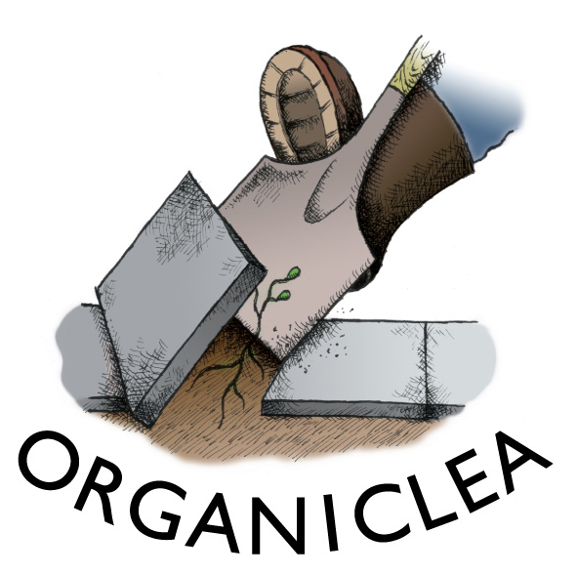
Organiclea Community Growers

Purchasing Policy

In our food work we know the importance of two key issues: keeping the consumer-producer chain as short and direct as possible; and being aware of the environmental impacts of a product and its packaging (at all stages of production, sale, delivery and use). The factors we take into consideration when buying food can also be applied to all the other materials we need for our work. These factors can be characterised according to the principles of permaculture – earthcare, fairshares, and peoplecare.

We recognise that pragmatism is needed (for example sometimes price has to be a key consideration or speed is of the essence), and it is difficult to make absolute right/wrong judgements; but the questions and considerations outlined here should help us to make good decisions about the purchases we choose. They are designed to be used in conjunction with the establishment of a ‘preferred suppliers’ list and supporting all involved in Organiclea’s work to educate themselves about these issues.

Earthcare
Before buying something, we need to think about the environmental impact of the product, both in its production, its delivery to us and its ultimate use. Then consider:
- Can we avoid this impact altogether by borrowing rather than buying, or choosing reusable items rather than disposable? For example, at Hawkwood and at the Hornbeam Café there is plenty of crockery and cutlery that can be borrowed
- Is there a hand-operated rather than fossil-fuel powered choice?
- Are there choices to make which minimize packaging?
- Is there a specific environmentally-friendly option for this product? For example if disposable crockery is needed, is it biodegradable rather than plastic?
- Is there an option to buy secondhand rather than brand new?
- Is there a quality issue to consider – it might be better to spend more on a longer-lasting product rather than a cheaper version which breaks sooner.

Fairshares
In terms of permaculture fairshares, beyond considering whether we really need the item, there are some considerations to make in where we buy something from:
- Can we avoid using supermarkets (which play a detrimental part in the agro-industrial food system we are seeking to change), and other large scale chain stores where profit is creamed off for faceless shareholders?
- Can we avoid using online giant corporations like Amazon (renowned for avoiding tax) which employ workers in non-meaningful jobs and also often mean a separate transport journey for each item ordered?
- Can we support the local economy by using small-scale independent shops in our area?

Peoplecare
There are also considerations for the impact of our purchases on other people:
- Can we find an explicitly fairtrade option?
- Is there a co-operative organisation providing this product which we can support?
- Can we use a local or small-scale supplier with whom we can develop a direct human relationship?

Agreed by the co-operative
1 December 2014

